*** Southwest***

***Software Development Team***

**Web and Database Design**

**CA2 - Due date: 23/4/2012**

**Band Website**

**Land Lovers**

***Planning Document***

**Design & Development Team:**

**James Madden: X00086390:**

**Shane Murphy: X00085315:**

**Maciej Macierzynski: X00086366:**

Table of Contents

Basic company contact information 3

Purpose 3

Company description 3

Current website success details (and challenges) 3

New Site Organisation 4

Site and Domain Names 4

Personal website preferences 4

Audience and prospect profile 5

Design and layout interests 6

Specific page content 6

Required content: 6

Extra functionality: 6

Main keyword phrases for search engine optimization (SEO) 6

Table of Figures

Figure 1 Current Website 3

Figure 2 Website Layout 4

Figure 3 Audience Profile Chart 5

Figure 4 Album Cover 6

Figure 5 Image 6

# Basic company contact information

Shane Murphy – 087 280 6262 – X00085315@ittd.ie

Padraig Cooney – 086 173 5864 - padraig@landloversmusic.com

Brian Lynch – 086 107 3571 - brian@pod.ie

# Purpose

The site has a number of specific purposes, underlying the general purpose to provide fans with up to date information on the bands activities.

* To make available various **media** for fans (Audio, Video).
* To provide **basic information** on the band.
* To gain a **favourable impression** of the band.
* To **sell** albums through 3rd party websites.
* To strengthen **brand identification**.
* To make available **Gig listings** to fans.
* To provide a **central hub** for all band activity.

# Company description

Land Lovers are a Dublin based Quintet. They play wordy pop and folk based indie music, sometimes likened to Elvis Costello and The Attractions, XTC etc.

They are founding members of the Popical Island collective, which has become a central hub of pop music in Ireland and is now home to the likes of Tieranniesaur, Yeh Deadlies, Squarehead and Groom. Land Lovers play a central role in its various undertakings.

# Current website success details (and challenges)

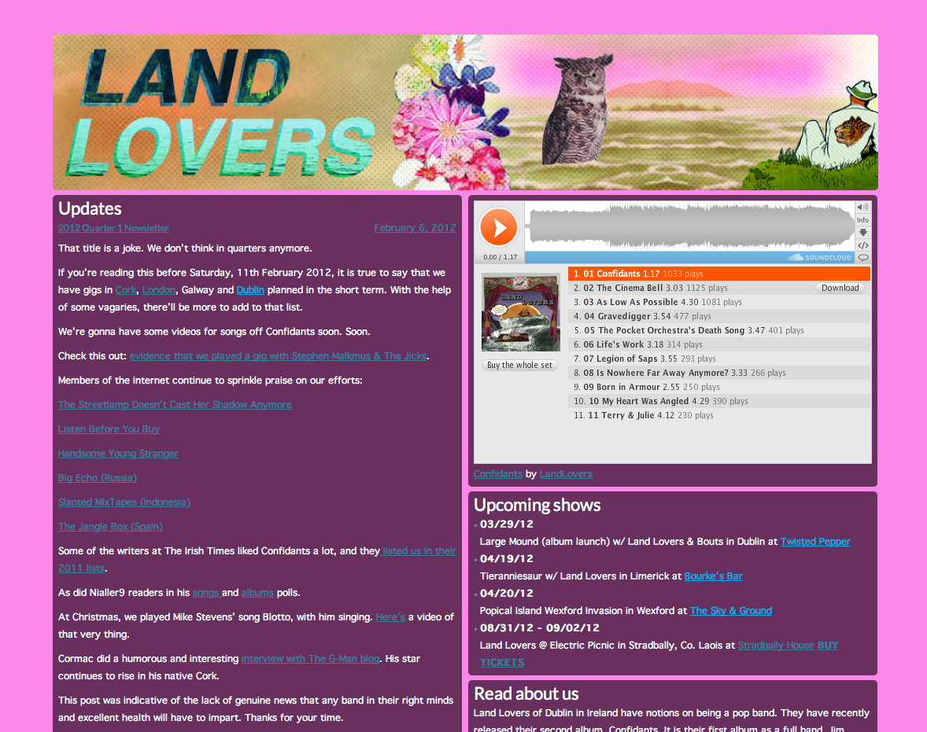

Figure Current Website

The current website is a wordpress based template bought from <http://slates.tomodoherty.ie> It is a functional and simple design. It has succeeded in providing a central hub for all band activity. However, it is not aesthetically pleasing and is generally neglected and out of date.

# New Site Organisation

The new site is organized in a networked style of organization. The main site will consist of mesh style navigation, while some anchored pages will sit in a hierarchical tree style format.

This approach allows pages to be grouped logically based on content, while also allowing for quick navigation between pages. There is no dedicated navigation bar for any of the pages, instead a common menu consisting of Biography, Discography, Media and Contact will be employed in all pages.

Figure Website Layout

# Site and Domain Names

**Site Name on Masthead**: Land Lovers

**Domain Name**

Domain name: <http://landloversmusic.com>

**Already Registered:** Yes

# Personal website preferences

The website should be enjoyable to browse and aligned with the bands ‘quirky’ ‘Popical’ image. The design should not impact on the content. Content should be legible and up to date. Information should be accessible in as little clicks as possible. The site should be W3C compliant and be checked with http://validator.w3.org/

# 

# Audience and prospect profile

# Macintosh HD:Users:shanemurphy:Desktop:Screen Shot 2012-03-27 at 16.18.41.png

Figure Audience Profile Chart

Demographics suggest that the most likely people to browse the site are between the ages of 18 to 35 with a slight weighting towards a male audience.

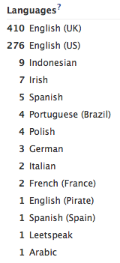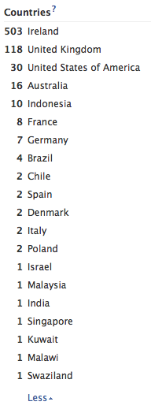

Demographics suggest that the most likely people to browse the site are English speakers from the UK and Ireland other languages of note are Indonesian, Portuguese and Spanish.

# Design and layout interests

The website should have a fun and quirky presentation. A colour scheme which reflects the album artwork of the most recent release by the band would be desired.

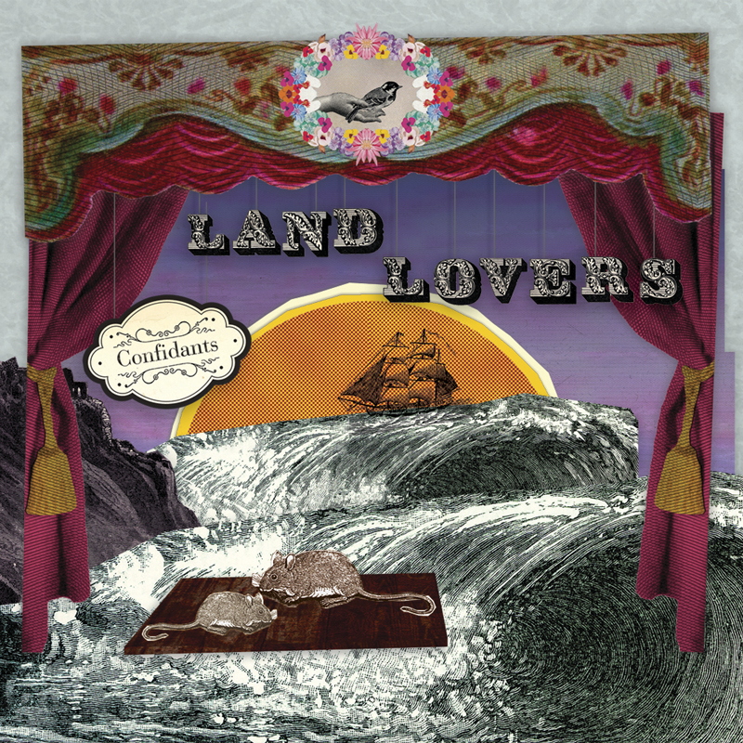

Figure Album Cover

The band, have used Owls as an image representing the band in the past and continue to do so. This could also be worked into the website.

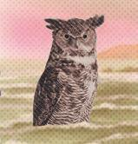

Figure Image

# Specific page content

## Required content:

Biography, News updates, Gig listings, Discography and contact details.

## Extra functionality:

Song Lyrics, Integration with Tumblr for news updates, Facebook like button and a downloadable press pack.

# Main keyword phrases for search engine optimization (SEO)

* Land Lovers
* Landlovers
* Dublin
* Ireland
* Indie
* Indie-pop
* Folk rock alt
* Alternative
* Popical
* Popical island
* Confidants
* Romance
* Immovable feet